###### IMAGE GALLERY

###### A MINI PROJECT REPORT

###### Submitted by

###### Group: G30

**KESHAV GUPTA, 2410993043,**

**KUSHAN GARG, 2410993053,**

**YASHIT MITTAL, 2410993075,**

###### *in partial fulfillment for the award of degree*

###### *of*

###### 

###### BACHELEOR OF ENGINEERING

***in***

CSE-AI



**CHITKARA UNIVERSITY**

**CHANDIGARH-PATIALA NATIONAL HIGHWAY**

**RAJPURA (PATIALA) PUNJAB-140401 (INDIA)**

###### september & 2024

###### TABLE OF CONTENTS

|  |  |  |
| --- | --- | --- |
| Sr.no | **Section** | **Page no** |
| **1.** | Introduction | 1 |
| **2.** | Problem Statement | 2 |
| **3.** | Goals | 3 |
| **4.** | Features | 4 |
| **5.** | Tech Stacks | 5 |
| **6.** | Results | 6-7 |
| **7.** | References | 8 |
| **8.** | Conclusions | 9 |

###### 

**INTRODUCTION**

In today's digital world, images are often more impactful than words, and there is a need for a well-organized and visually appealing site to share images. Our Image Gallery Website Project is addressing this problem head on with a full-featured, responsive, user-friendly experience for uploading, organizing, and sharing images.

This project is built for many different types of users: photographers, designers, businesses or casual users creating a personalize or professional online gallery. Additionally, this site allows the users to showcase their visual content and to engage with their images in a unique web experience using the latest web technology.

**PROBLEM STATEMENT**

* + Today's world is image-centric. Everyone needs a simple, accessible, and secure solution to manage and display images online, including individuals and businesses as well as creative professionals. Current image management tools miss the mark in several key areas, including simplicity, customization, searchability, and scope.
  + The **Image Gallery Website Project** aims to solve these issues by providing an affordable, feature-rich platform that emphasizes ease of use, advanced organization capabilities, robust security, and a mobile-responsive design. Our goal is to create a scalable solution that empowers users to efficiently manage and share their images while maintaining full control over privacy and presentation.
  + The present undertaking can be described as a balance between design, functionality and user experience. We aim at providing a solution that goes beyond the mere practical aspect of the users and allows them to showcase their visual narratives in a more professional and exciting way.

**GOALS**

* + To develop a visually attractive, user-friendly platform to manage and display images on the Internet.
  + To provide advanced features such as image grouping (or categories), search, and tagging for an efficient organization.
  + To create a responsive and mobile-friendly interface that works well across a wide range of devices.
  + To establish high standards of security and privacy for user-uploaded content.
  + To develop a reliable, high-performance website that can accommodate large numbers of images and users.

**FEATURES**

**User-Friendly Interface**: Designed for simplicity, the intuitive dashboard allows users of all levels to easily manage images, create galleries, and personalize content with ease.

**Advanced Search and Filtering**: Users can quickly sort and organize large image collections using filters like categories, tags, dates, and metadata for efficient searching.

**Responsive Design**: Optimized for all screen sizes, the platform ensures a consistent visual experience across mobile, tablet, and desktop devices.

**High-Quality Image Display**: Images are optimized for fast loading while maintaining high quality, ensuring a smooth and visually appealing browsing experience.

**TECH STACKS**

**HTML STRUCTURE OF WEB:**

HTML forms the foundation of the website, providing the structural layout for all content.

**ROLE**: Organizes images into grids and galleries. And defines the basic elements like text, buttons, and links.

**BENEFITS:** Ensures accessible and well-organized content along with optimization for SEO and cross-browser compatibility

**CSS-DESIGNING**:

CSS is responsible for styling and designing the visual aspects of the website.

**ROLE**: Controls the appearance of the image galleries, text, and layout along with Implements responsive design, ensuring the website looks great on all devices.

**BENEFITS**: Creates a visually appealing and consistent design.

**RESPONSIVE AND INTERACTIVE UI WITH CSS**:

CSS ensures that the website adapts seamlessly to different screen sizes.

**ROLE**: Media queries are used to make the website fully responsive for mobile, tablet, and desktop devices. And Hover effects and other interactive styles enhance the user experience.

**BENEFIT:** Smooth, engaging interactions. And Optimized layouts for every device.

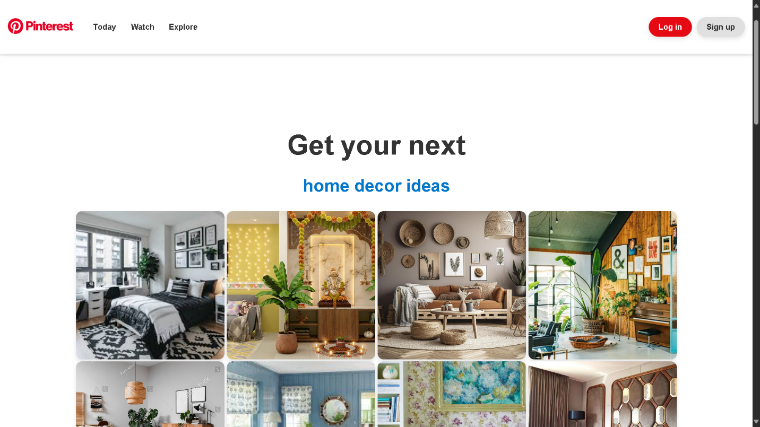**RESULTS WITH EXPLANATION**

The HTML provides the basic structure of the page, including a header with a logo, navigation links, and buttons for login/signup. The main content consists of a heading and a grid of images showcasing home decor ideas. Each image may link to more detailed content or external pages.

The CSS styles the page, ensuring a clean and modern design. The layout is created using Flexbox or CSS Grid to make the image grid responsive across various devices. Fonts, image sizes, and spacing are customized to ensure a visually appealing and user-friendly interface. The responsive design adapts the layout to different screen sizes, making the website functional on desktops, tablets, and mobiles.

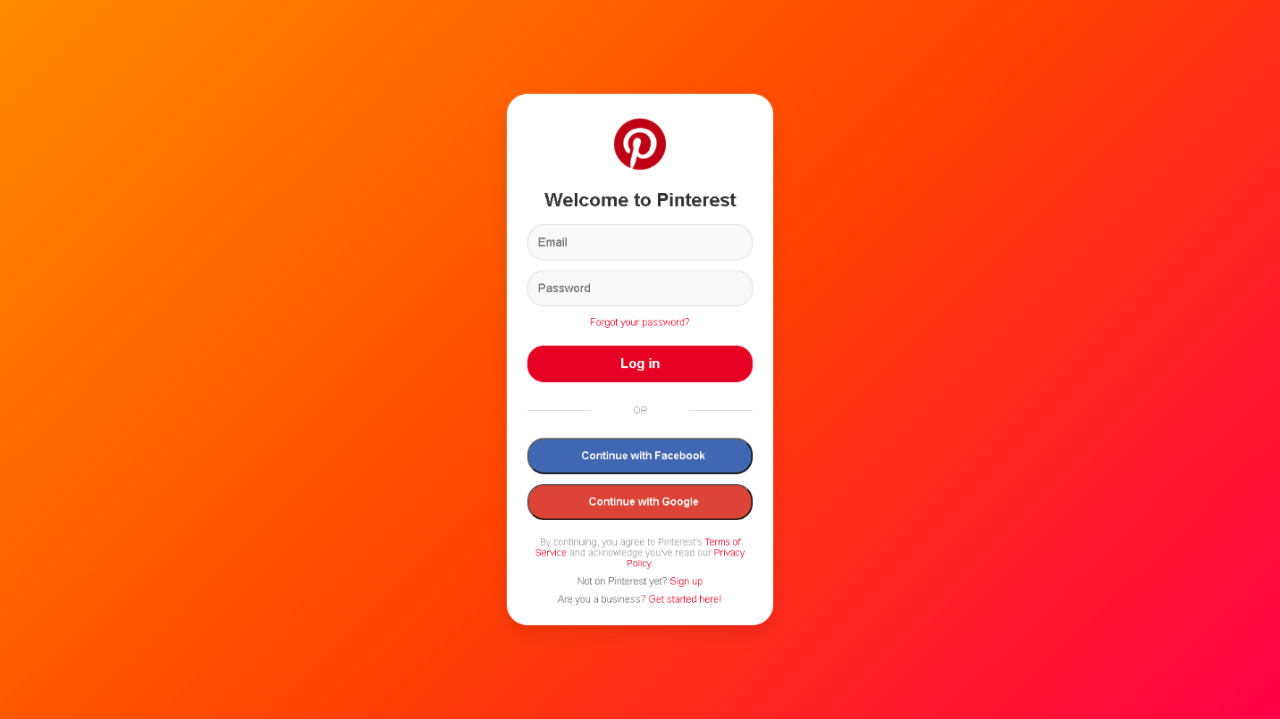**LOGIN PAGE**

The HTML structure of the login page includes a header displaying the Pinterest logo and a form for user authentication. The form consists of fields for entering an email and password, along with options for users to log in via Facebook or Google. It also features helpful links for password recovery, signing up for a new account, and accessing the terms of service and privacy policy.

The CSS enhances the login page's visual appeal and usability. It centers the form on the page, creating an inviting user experience. The vibrant gradient background adds a modern touch, while rounded input fields and distinct buttons (with prominent colours for the login button) enhance usability. The design is responsive, adapting seamlessly to various screen sizes, ensuring a consistent experience on both mobile and desktop devices.

Overall, the HTML and CSS work together to create a user-friendly and visually appealing login page that facilitates easy access for users.

**REFRENCES**

Throughout the development of the **Image Gallery Website Project**, various resources were consulted to ensure the implementation of best practices in web development. The following references provided valuable insights and guidance:

**1. Google Search**

Used extensively to gather information, troubleshoot issues, and explore examples of similar projects and best practices for HTML and CSS implementation.

**2. Official Documentation**

**HTML and CSS Documentation:** Resources from MDN Web Docs and W3Schools were consulted for best practices, coding standards, and technical explanations.

**3. AI Models**  
Insights were derived from AI-based tools to assist in code generation, image optimization suggestions, and design enhancements.

**4. YouTube Videos**  
Tutorials from various YouTube channels provided in-depth explanations and examples of responsive design, CSS animations, and interactive elements.

**5. Pinterest Official Website**  
Design inspiration for layout and image grid styles was drawn from the Pinterest platform, helping guide visual elements and UI/UX principles for the gallery structure.

**CONCLUSIONS**

The Image Gallery Website Project aims to offer a complete and easy-to-use system for managing, promoting and distributing images. This project focuses on effective navigation, design maturity and improved function and answering a growing demand from photographers, artists, companies and even occasional users.

This project embodies a well-thought-out combination of design, function, and technology to provide an engaging solution for the users who require an easy-to-use but a powerful platform for organizing their images. Along the lines, the Image Gallery Website has sustainable development and growth with the addition of new features and enhancements overtime, increasing its value and the user experience respectively.